Introduction
This project focuses on applying predictive modeling techniques to a logistics dataset to predict delivery time. The Logistics Dataset was used for the analysis. The objective was to develop machine learning models, evaluate their performance, compare different approaches, and propose practical optimization strategies for logistics operations.

2. Problem Definition
The main objective of this project is to predict the number of days required for delivery of a shipment. The target variable selected for prediction is Delivery_Days. Accurate delivery-time prediction can help logistics organizations identify potentially delayed shipments, improve resource allocation, and support better delivery planning.

3. Dataset Description
The Logistics Dataset was used for this project. After preprocessing, the dataset contained 41,652 rows and 52 columns. Missing values and duplicate records were removed during the preprocessing stage. The target variable for this project was Delivery_Days.
Item | Details
Dataset | DataCo Supply Chain Dataset
Rows | 41,652
Columns | 52
Target Variable | Delivery_Days
Missing Values | 0
Duplicate Rows | 0

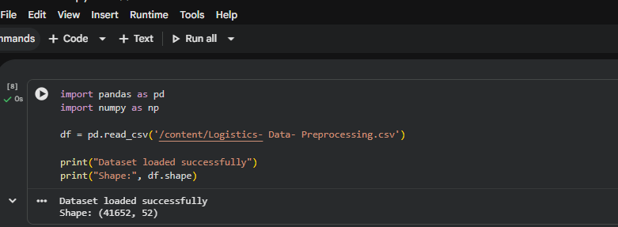

4. Feature Selection
Nine logistics-related features were selected as input variables for the predictive models. The feature Days for shipping (real) was initially considered but was removed because it showed an extremely high correlation with the target variable and could cause target leakage. Removing this feature helped create a more appropriate predictive modeling setup.
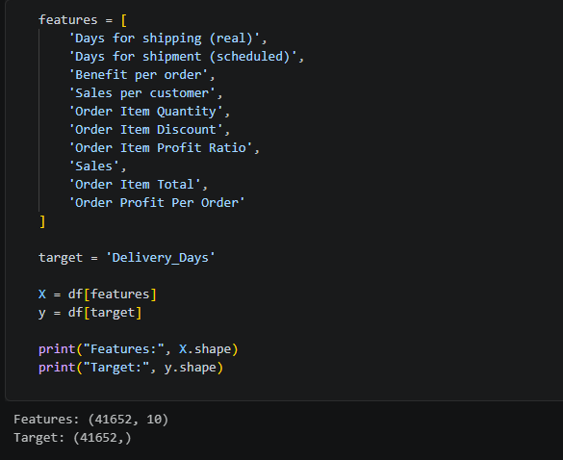

5. Data Preparation
The cleaned dataset was divided into input features (X) and the target variable (y). The dataset was divided into 80% training data and 20% testing data using a fixed random state of 42. The training dataset contained 33,321 records, while the testing dataset contained 8,331 records.
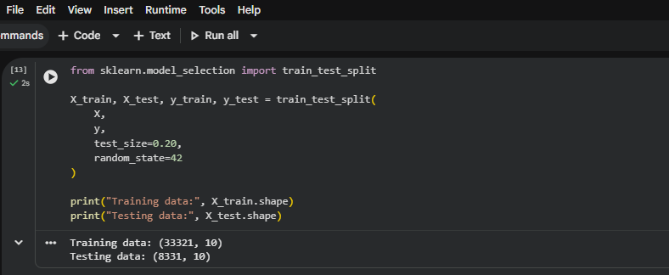

6. Model Selection
Linear Regression
Linear Regression was selected as a baseline regression model because it is simple, easy to interpret, and useful for establishing a basic prediction benchmark.
Random Forest
Random Forest Regression was selected as a second model because it can capture non-linear relationships between logistics features and delivery time and can also provide feature-importance information.

7. Model Training and Evaluation
Linear Regression
linear_model = LinearRegression()
linear_model.fit(X_train, y_train)
y_pred_linear = linear_model.predict(X_test)
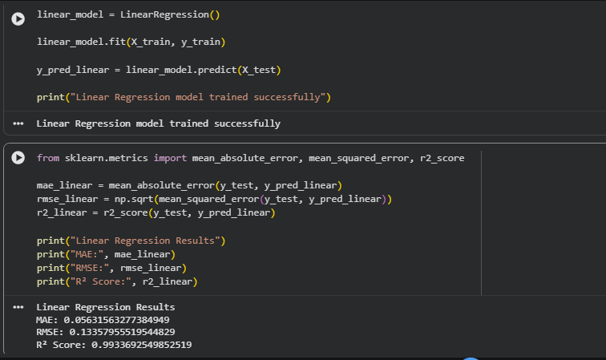
Random Forest
rf_model = RandomForestRegressor(
n_estimators=100,
random_state=42,
n_jobs=-1
)
rf_model.fit(X_train, y_train)
y_pred_rf = rf_model.predict(X_test)
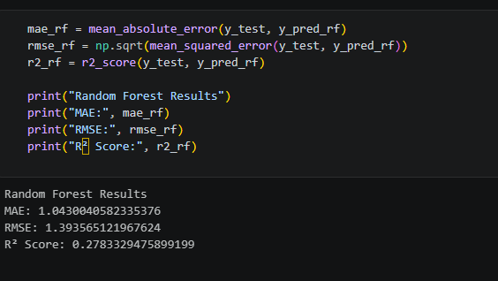

8. Evaluation Metrics
Three evaluation metrics were used: Mean Absolute Error (MAE), Root Mean Squared Error (RMSE), and R² Score. MAE represents the average absolute prediction error. RMSE measures prediction error while giving greater weight to larger errors. R² indicates how much variation in the target variable is explained by the model. Lower MAE and RMSE and higher R² indicate better performance.

9. Model Performance Comparison
Model | MAE | RMSE | R² Score
Linear Regression | 1.1309 | 1.3982 | 0.2735
Random Forest | 1.0430 | 1.3936 | 0.2783
Random Forest performed slightly better than Linear Regression. It achieved a lower MAE and RMSE and a slightly higher R² Score. Therefore, Random Forest was selected as the final model.
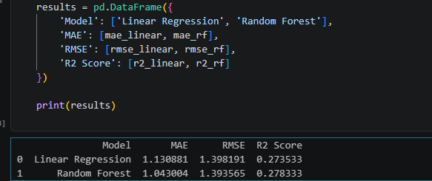

10. Cross-Validation
Five-fold cross-validation was performed to check whether the model's performance was reasonably consistent across different subsets of the dataset. The R² scores obtained were 0.0886, 0.2374, 0.3487, 0.4472, and 0.2229. The mean cross-validation R² score was 0.2690.

11. Feature Importance
Feature importance from the Random Forest model was used to understand which variables contributed most strongly to the predictions. Days for shipment (scheduled) was the most important feature, with an importance score of approximately 0.4852. This indicates that the scheduled shipment duration was the strongest predictive feature among the selected variables.
Feature | Importance
Days for shipment (scheduled) | 0.485221
Order Profit Per Order | 0.107151
Benefit per order | 0.106849
Order Item Discount | 0.080452
Order Item Profit Ratio | 0.074936
Order Item Total | 0.047910
Sales per customer | 0.047772
Sales | 0.026197
Order Item Quantity | 0.023512
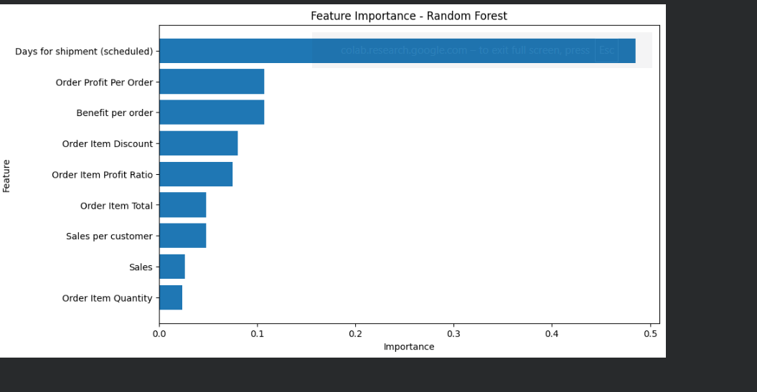

12. Actual vs Predicted Delivery Time
A sample prediction was also generated using the Random Forest model. For one test record, the actual delivery time was 2 days while the predicted delivery time was approximately 3.58 days. Individual predictions may differ from actual values; therefore, overall evaluation metrics were used to assess model performance.
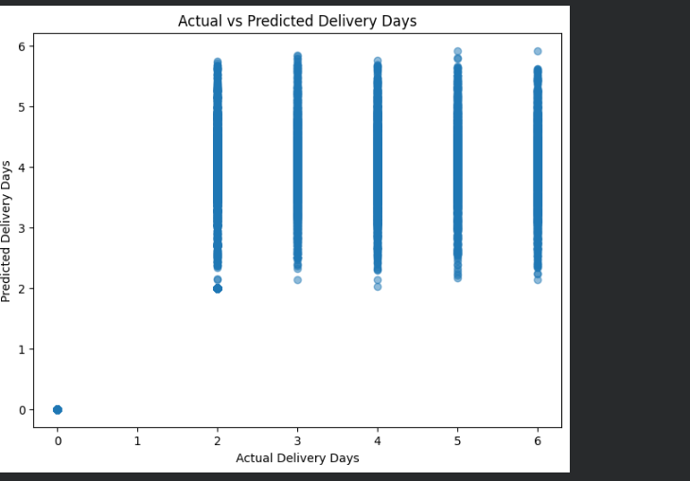
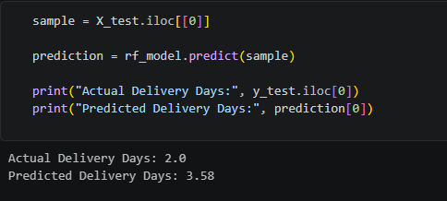

13. Optimization Strategies

1. Shipment Prioritization
Shipments predicted to require longer delivery times can be prioritized for monitoring and faster processing.

2. Resource Allocation
Warehouse, transportation, and delivery resources can be allocated more efficiently based on predicted delivery requirements.

3. Schedule Improvement
The strong importance of scheduled shipping duration suggests that logistics teams should review shipment schedules and reduce unnecessary delays.

4. Early-Warning System
The prediction model can be used to identify shipments that may require more delivery time and allow teams to take preventive action.

5. Continuous Monitoring
The model can be periodically retrained using new logistics data so that predictions remain useful as operational patterns change.

14. Conclusion
This project demonstrated the use of predictive modeling for logistics delivery-time forecasting. Two regression models, Linear Regression and Random Forest Regression, were developed and evaluated using MAE, RMSE, and R² Score. Random Forest achieved the better performance with an MAE of 1.0430, RMSE of 1.3936, and R² Score of 0.2783. Five-fold cross-validation produced a mean R² score of 0.2690. The feature-importance analysis showed that scheduled shipment duration was the most influential feature. The model insights can support shipment prioritization, resource allocation, schedule improvement, and early identification of potentially delayed deliveries.

